L.A. County Climate Vulnerability Assessment
Partner Social Media Toolkit
October 13, 2021

Report details
Climate Vulnerability Assessment website
Final Report
Final Map

Blog post
CSO’s lead staff on the CVA shares her perspective on the study, its findings, and next steps in our newest blog post.

Sample social media posts
Starting at 11 am, please use these following sample posts to share to your social media platforms. Please use #CVALA and tag @CountyofLA and @CSO_LACo in your posts.

Download graphics here

The worst damage from climate change comes from doing nothing. A new Climate Vulnerability Assessment details which L.A. County neighborhoods will be hardest hit by 2050 so we can start planning right now to protect our most vulnerable residents. #CVALA https://ceo.lacounty.gov/2021/10/07/uncategorized/feeling-the-heat-whos-most-vulnerable-in-l-a/
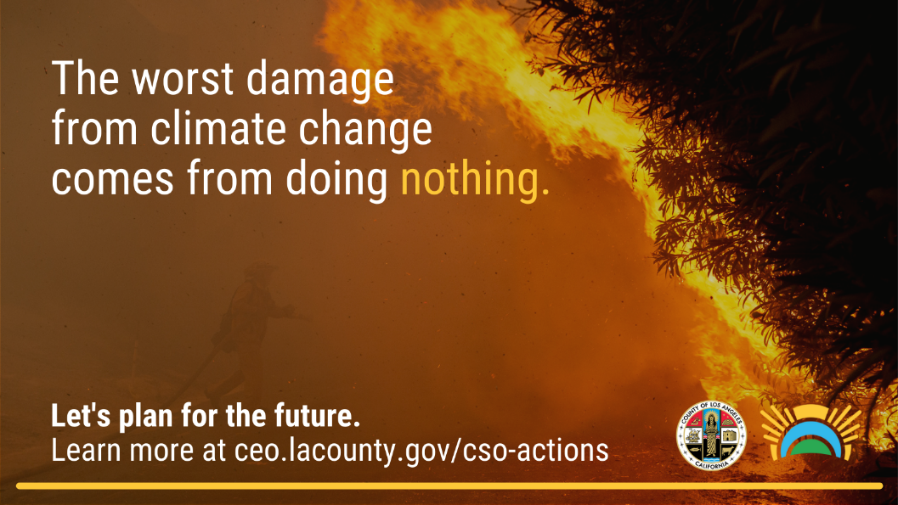

What types of workers face danger during extreme weather events? Not just those who work outside. Learn more in the just-released L.A. County Climate Vulnerability Assessment. #CVALA https://ceo.lacounty.gov/cso-actions/
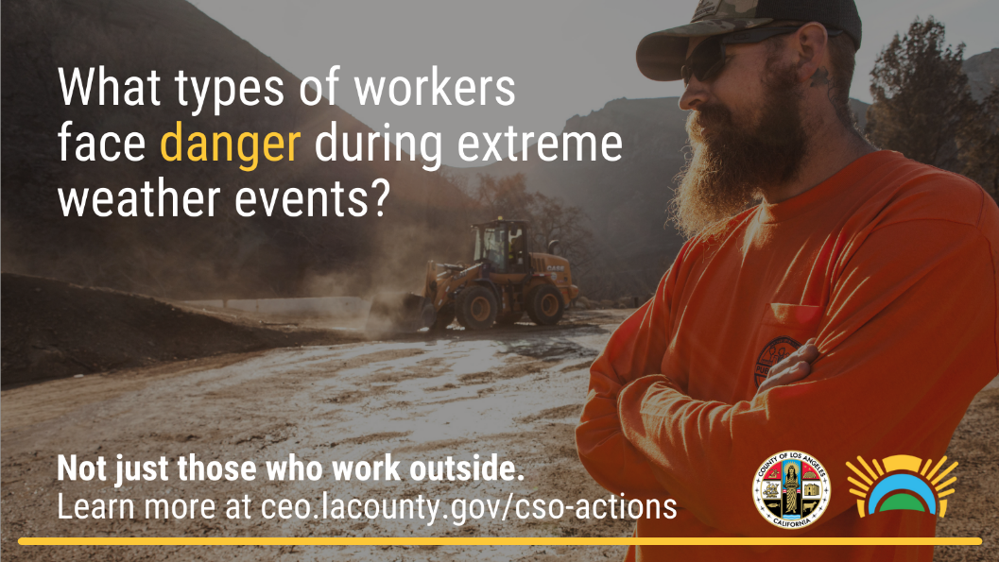

From Bellflower to Santa Clarita, 47 communities in L.A. County have been highlighted as extremely vulnerable to climate change hazards in a new Climate Vulnerability Assessment from @CSO_LACo. See how your neighborhood stacks up. #CVALA https://ceo.lacounty.gov/cso-actions/
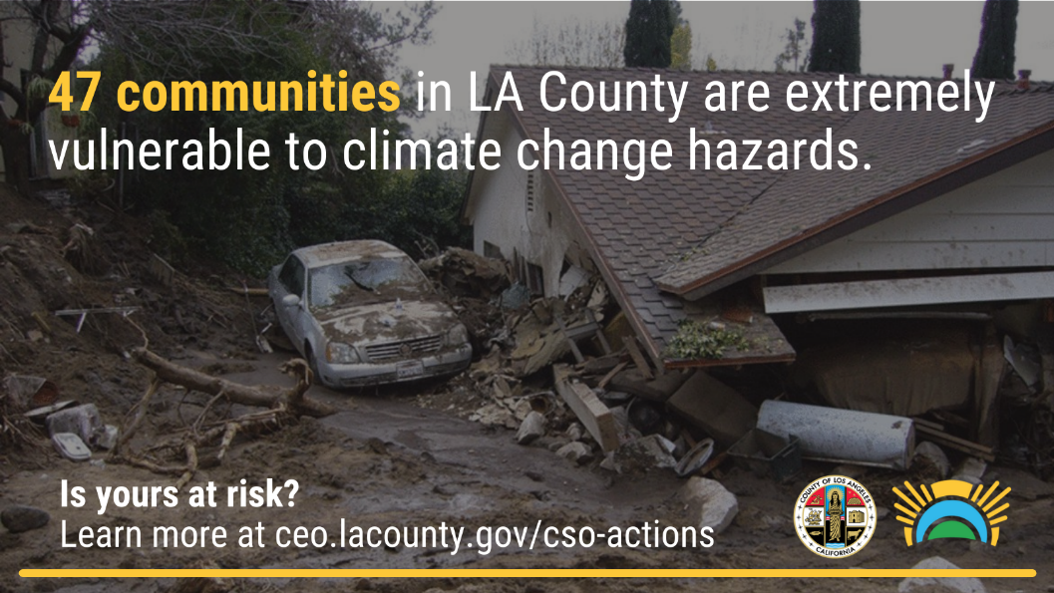

A disaster can happen in seconds … or over decades. Check out our new Vulnerability Assessment to find which L.A. County neighborhoods will be hardest hit by severe climate impacts by 2050. #CVALA https://ceo.lacounty.gov/cso-actions/
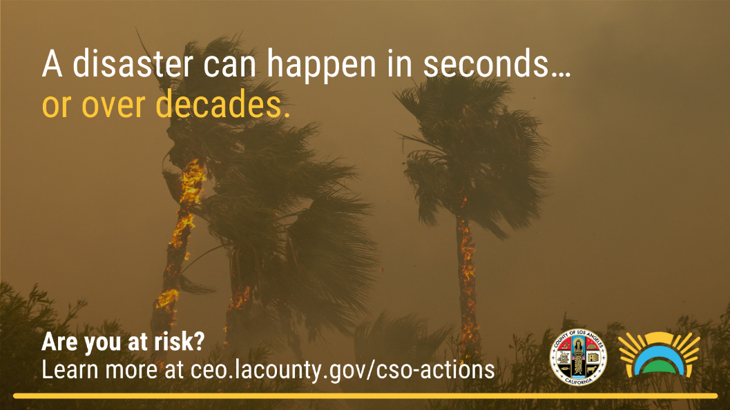
More than half of L.A. County residents live in a community at high risk of exposure to at least one of five severe climate impacts, according to a new Climate Vulnerability Assessment from @CSO_LACo. Find out if your neighborhood is in harm’s way. #CVALA https://ceo.lacounty.gov/cso-actions/

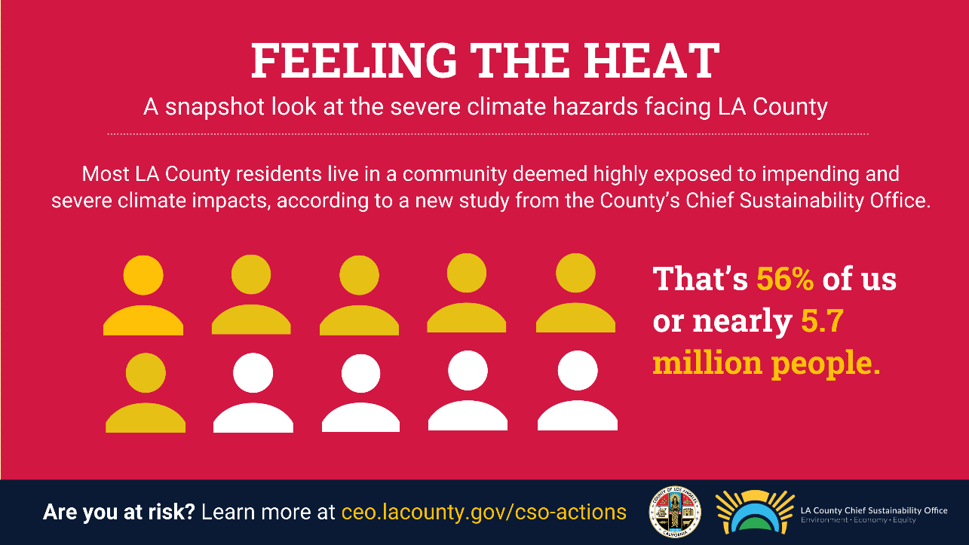

Low-income and communities of color are disproportionately vulnerable to severe climate impacts, according to a new Climate Vulnerability Assessment from @CSO_LACo. Learn more about which neighborhoods will be hardest hit. #CVALA https://ceo.lacounty.gov/cso-actions/
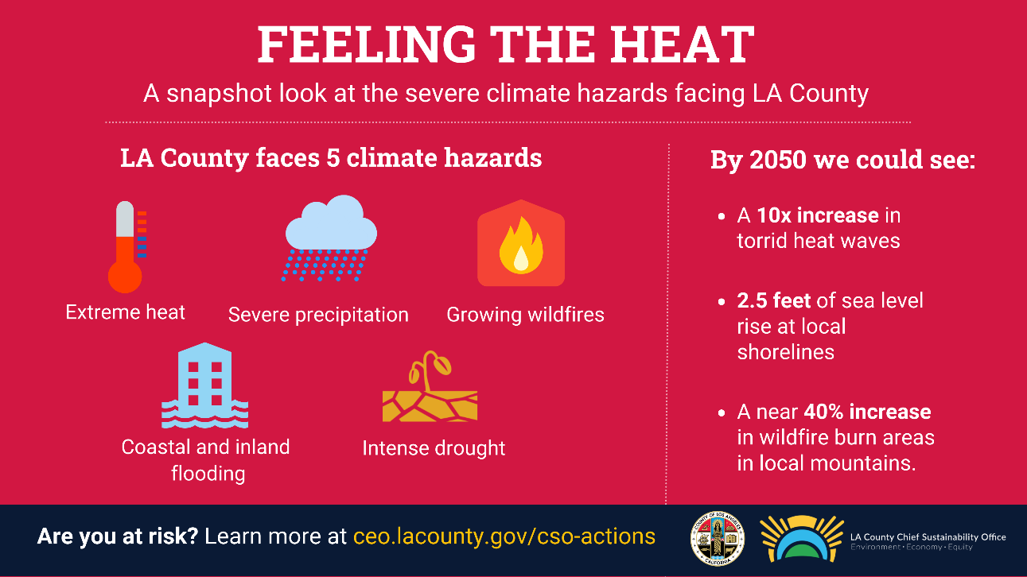

Climate hazards hit very close to home in 47 highly vulnerable LA County communities identified in a new Climate Vulnerability Assessment. Find out if you’re at risk. #CVALA https://ceo.lacounty.gov/cso-actions/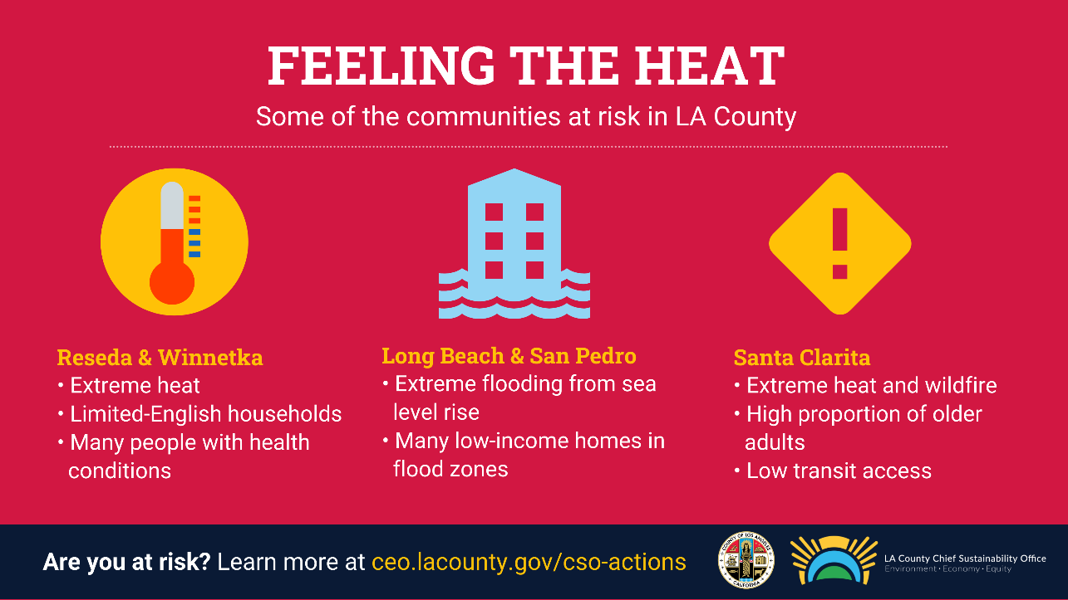

Nearly 1 in 5 LA County residents face dual dangers of increase exposure to climate hazards and a high susceptibility to negative impacts according to new @CSO_LACo report. #CVLA https://ceo.lacounty.gov/cso-actions/

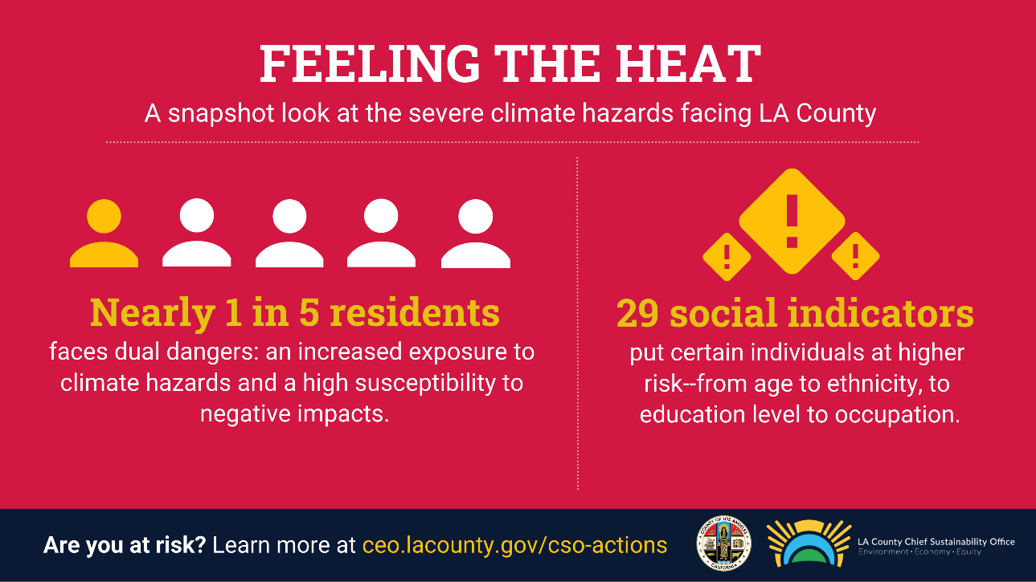

Shareable Infographic

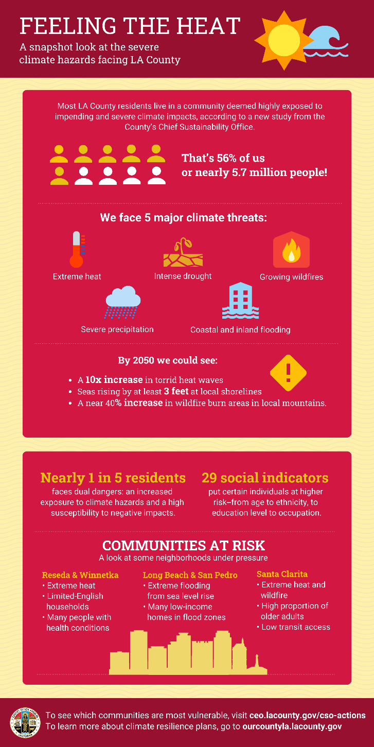

General Report Background

Why Was This Study Conducted?
- No one had done a local analysis of which highly susceptible people and facilities are likely to be exposed to climate hazards and how that might affect them. This information will be crucial to taking actions regionwide to lessen potential harm.

High Level Messaging Points
- More than half of residents – nearly 5.7M people -- live in a neighborhood that has a high exposure to at least one of five severe climate threats – extreme heat, wildfire, drought, extreme precipitation and sea-level rise.

- Nearly 1 in 5 residents are highly vulnerable – meaning they have both high-risk exposure to climate hazard AND low capacity to prepare for, withstand and recover from debilitating impacts.

- Low-income and communities of color are disproportionately exposed to severe climate threats and disproportionately live in areas that are socially vulnerable to impacts.

What Can Be Done?
- There’s nearly $15B available in state funding to help California plan and prepare for climate threats. This data will help guide how that money might be spent locally helping the LA region make sure we invest in the areas that are most vulnerable.

- The vulnerability assessment acts as a companion piece to the Our County Sustainability Plan, the nation’s most ambitious regional blueprint for community sustainability.

- Its findings will guide future priorities for implementation of the Plan, which includes increasing the tree canopy in low-income urban areas and limiting development in high-impact climate zones.

